Title: | Digital Output Requirement Specification
Distribution
Author | Paul Li  Vincent Liu | Date: 2013-12-06
Review | See review section | Date: See review section
Approved
Remarks

Contents

1 Introduction 3
1.1 Scope 3
1.2 Definitions, acronyms, and abbreviations 3
2 Overall description 4
3 Assumptions and dependencies 6
3.1 Assumptions 6
3.2 Dependencies 6
4 Non-functional requirement 7
5 Functional requirements 8
6 Digital Output Subsystem Documentation 9
7 References 9
8 Revision History 9
9 Requirement Review 10
9.1 Decision of the Review: 10
9.2 Check list: 10
9.3 Remarks: 10
9.4 Defects 10
9.5 Changes are proved: 10

List of Figures

Figure 1: CB software architecture 3
Figure 2: Digital Output Subsystem Use Case Diagram 5

Introduction

Scope
This document is intended to specify the software requirements for the Digital Output Subsystem of VT5 in detail. The CB software architecture is showed as Figure 1.
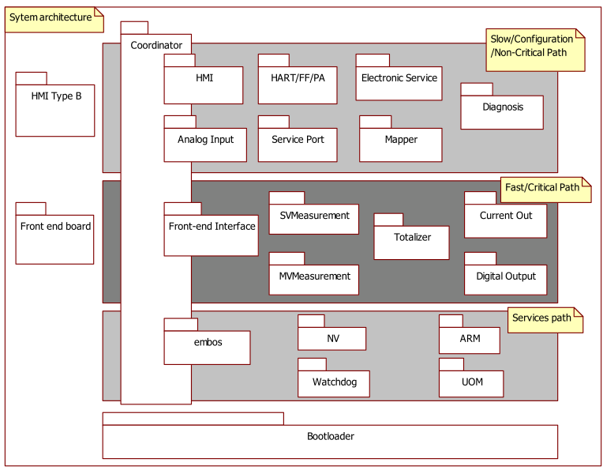
Figure 1: CB software architecture

The Digital Output Subsystem design, implementation and black – box testing will be based on the requirements listed herein.

Definitions, acronyms, and abbreviations

Term | Definition
Diagnostic Subsystem | Subsystem responsible for handling error conditions and warnings.
HART Subsystem | Subsystem for interfacing to HART (Highway Addressable Remote Transducer) protocol communications.
HMI Subsystem | Subsystem providing Human Machine Interface for local user access via display and key input.
NV | Non-volatile
MVMeasurement | Multi-Variable Measurement, mainly mange the Qn,Qm,Qp, QvPartial,QnPartial,
TOT | Abrreviation of Totalizer Subsystem
MVM | Abrreviation of MVMeasurement Subsystem

Overall description

The Digital Output Subsystem is intended for delivering one digital signal for output on dedicated hardware port-lines. The signal-source for these digital outputs is derived from a HMI (also HART and PA/FF) supplied configuration. Briefly this can be a simple logic signal, or it can be a pulse-train representing the measured flow value or alternatively a frequency representing another process value.
For all other uses, see Figure 2: Digital Output Subsystem Use Case Diagram.

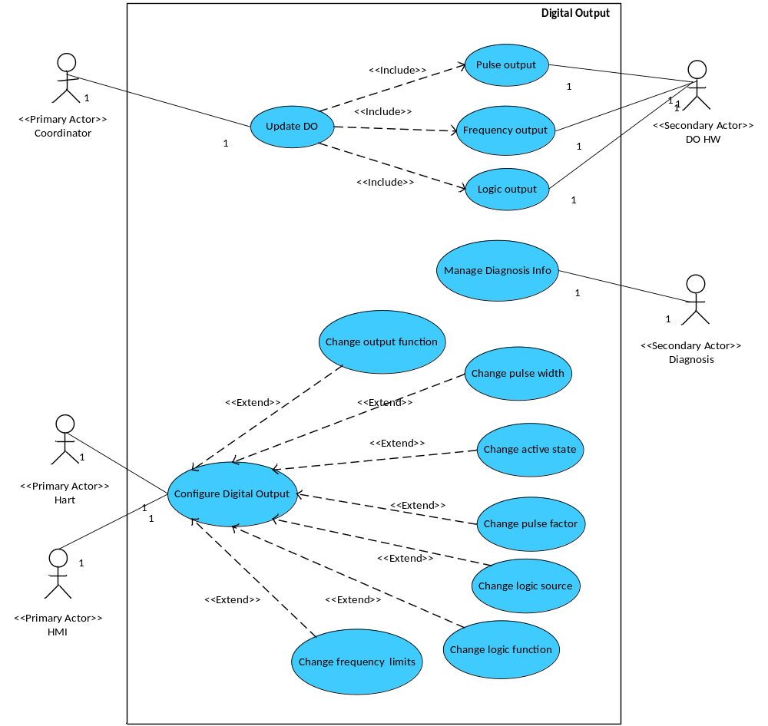
Figure 2: Digital Output Subsystem Use Case Diagram

Assumptions and dependencies

Assumptions
- The Digital Output Subsystem will be triggered by the coordinator. Therefore it is assumed that triggers for the Digital Output Subsystem will be provided through interface methods in the Digital Output Subsystem and likewise the external subsystems will have to provide interface methods for the Digital Output Subsystem to use for passing result data out to them.
- External Subsystems (in that case the MVM Subsystem) will provide all device / output variables that should be readable by the Digital Output subsystem.
- Digital Output 1 can act as pulse-train or frequency output.

Dependencies
- The Digital Output Subsystem will be developed for 2 wire extended Communication Board.
- Development and testing will be done regarding to the following conditions:
  - Compiler: IAR Compiler V3. 40
  - Framework: 2.3.1
  - Oscillator frequency: 3.686 MHz
  - CPU clock is oscillator frequency / 2 (for VT5)
  - System update rate / execution time: VT5 100 ms

Non-functional requirement
Ident. | Definition / Motivation | Priority  M | Source  [1]3.1.1
NFR_DO_1 | Digital Output shall be written in “C” language. Or Assembler Language. | Stability  C | Source  [1]3.1.1

Ident. | Definition / Motivation | Priority  M | Source  [1]3.1.3
NFR_ DO _2 | Digital Output shall be based on the common ABB framework concept. | Stability  C | Source  [1]3.1.3

Ident. | Definition / Motivation | Priority  M | Source  [1]3.2.1
NFR_ DO _3 | Digital Output shall pass pc-lint check. | Stability  C | Source  [1]3.2.1

Ident. | Definition / Motivation | Priority  M | Source  [1]3.2.1
NFR_ DO _4 | Digital Output shall pass pc-lint check. | Stability  C | Source  [1]3.2.1

Ident. | Definition / Motivation | Priority  M | Source  [1]3.2.2
NFR_ DO _5 | Digital Output shall have module test. | Stability  C | Source  [1]3.2.2

Ident. | Definition / Motivation | Priority  M | Source  [1]4.15.2.1
NFR_ DO _6 | Precautions must be taken not to lose any pulses.. | Stability  C | Source  [1]4.15.2.1

Functional requirements
Ident. | Definition / Motivation | Priority  M | Source  [1]4.15.1
FR_ DO _1 | Digital output shall configure to out Pulse regarding to flow rate. | Stability  C | Source  [1]4.15.1

Ident. | Definition / Motivation | Priority  M | Source  [1]4.15.1
FR_ DO _2 | Digital output shall configure to frequency output, regarding to flow rate or temperature. | Stability  C | Source  [1]4.15.1

Ident. | Definition / Motivation | Priority  M | Source  [1]4.15.1
FR_ DO _3 | Digital output shall configure to logic output. Regarding to diagnosis alarm. | Stability  C | Source  [1]4.15.1

Ident. | Definition / Motivation | Priority  M | Source  [1]4.15.2.1
FR_ DO _4 | Digital output shall output a user-defined number of pulses regarding to a programmable unit (e.g. nm³, m³ and kg). | Stability  C | Source  [1]4.15.2.1

Ident. | Definition / Motivation | Priority  M | Source  [1]4.15.2.2
FR_ DO _5 | The pulse width can be chosen between 1 to 256 ms. | Stability  C | Source  [1]4.15.2.2

Ident. | Definition / Motivation | Priority  M | Source  [1]4.15.2.2
FR_ DO _6 | Pulse factor range 0.001-1000Pulses/Unit. | Stability  C | Source  [1]4.15.2.2

Ident. | Definition / Motivation | Priority  M | Source  [1]4.15.2.3
FR_ DO _7 | When max flow too large to output, pulse output stop integration. | Stability  C | Source  [1]4.15.2.3

Ident. | Definition / Motivation | Priority  M | Source  [1]4.15.3.1
FR_ DO _8 | Output frequency mapped into the flow rate or Temperature. | Stability  C | Source  [1]4.15.3.1

Ident. | Definition / Motivation | Priority  M | Source  [1]4.15.3.2
FR_ DO _9 | Frequency range is from 1Hz – 10kHz. | Stability  C | Source  [1]4.15.3.2

Ident. | Definition / Motivation | Priority  M | Source  [1]4.15.4.1
FR_ DO _10 | When Alarm occurred. Contact output shall output a logic value regarding to the setting. | Stability  C | Source  [1]4.15.4.1

Ident. | Definition / Motivation | Priority  M | Source  [1]4.15.4.2
FR_ DO _11 | Normal open / Normal close is configurable by firmware thru HMI or Hart communication, default value is normal open in logic output. | Stability  C | Source  [1]4.15.4.2

Digital Output Subsystem Documentation

The following documents have to be generated for the Digital Output Subsystem:
- Software Design Description including performance data
- Test Plan
- Code review

References
Ref. | Document
[1] | [RS004]VT5 Software Requirement Specification

Revision History
Rev. | Description of Version/Changes | Primary Author(s) | Date
0.1 | Initial revision. | Paul.Li | 2011-09-14
0.2 | Update for VT5 | Vincent Liu | 2013-06-26
0.3 | Update some typos in section 3.2 | Vincent Liu | 2013-12-06

Requirement Review
Dept. | Name
R&D ShangHai | Lawrence Shi, Tongkun Liu | 2013-06-26 rev0.2

Dept. | Name
R&D ShangHai | Merrick Huang | 2014-01-06 rev0.3

Decision of the Review:
 | Decision | next steps
Y | Inspection passed without restrictions | Phase finished
 | Inspection passed with restrictions | some changes must be done
 | Inspection not passed | Inspection must be repeated

Check list:
 |  | yes | no | N.A.
1. | Does the specification explain the currently known requirements that the product finally has to perform? | Y
2. | Are complex subjects explained? | Y
3. | Are all used abbreviations and technical expressions explained? | Y
4. | Are all referenced documents in the reference list? | Y
5. | Contains the document a rough overview of the product’s main functionality? | Y
6. | Are all requirements referenced? | Y
7. | Are all requirements testable? | Y
8. | Is the typical environment of the product described? | Y
9. | Is defined which components already exist, will be bought or self-written? | Y
10. | Are safety requirements (e.g error-detection, error-handling) specified? | Y
11. | Are service/update requirements described? | Y
12. | Are all dependencies to other requirement documents considered? | Y
13. | Are templates used in a correct manner? | Y
14. | Are all open issues transferred to the defects table? | Y

Remarks:

Defects
No. | Checkpoint | Description | Major Defect | done  Date
1
2
3
4
4

Changes are proved:
The Reviewer confirms that all changes are done:
Proved Rev: | Date: | Reviewer:
0.2 | 2013-06-26 | Lawrence Shi, Tongkun Liu
0.3 | 2014-01-06 | Merrick Huang

